The Bucket System

Purpose: to allow a group of people to rapidly estimate items relative to each other. Estimation could be of value, effort, or some other useful information.

Constraints:
- Number of participants between 5 and 25
- Number of items to estimate greater than 40 or 50 and less than 20x the number of participants
- Fast, but not too accurate – should take about 30 to 90 minutes depending on the size of the group and the list of items

Process:
- Lay out cards with labels 0, 1, 2, 3, 4, 5, 8, 13, 20, 30, 50, 100, 200 on a wall or long table. These are the “buckets”.
- Choose one item to estimate at random from all the items. Place it in the “8” bucket.
- Choose a second item to estimate at random from all items. Discuss the item and, as a group, estimate it relatively to the first item. For example, if it is estimated at half of the first item, then it would be placed in the “4” bucket. All participants should agree on the placement.
- Choose a third item to estimate at random from all items. Discuss and place as in the previous step.
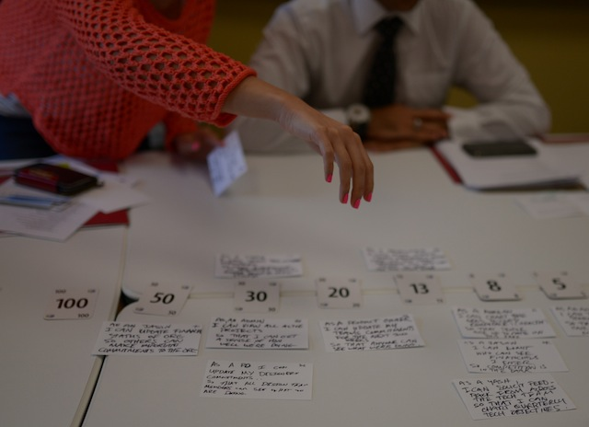
- Distribute the remaining items equally among participants. Participants then work independently through their items to estimate and place them in the appropriate buckets. If a participant feels unable to estimate an item, it can be passed along to someone else. The facilitator should make sure this passing-along does not get bogged down in any discussion.
- Once all the items are placed, the participants do a sanity check by independently looking for items they know well or care about and checking to see if they are in a “good” bucket. If a participant finds an item that does not seem to be in the correct bucket, then that item is brought to the attention of the group to discuss. NOTE: the facilitator should ensure that not too many items get discussed in detail.
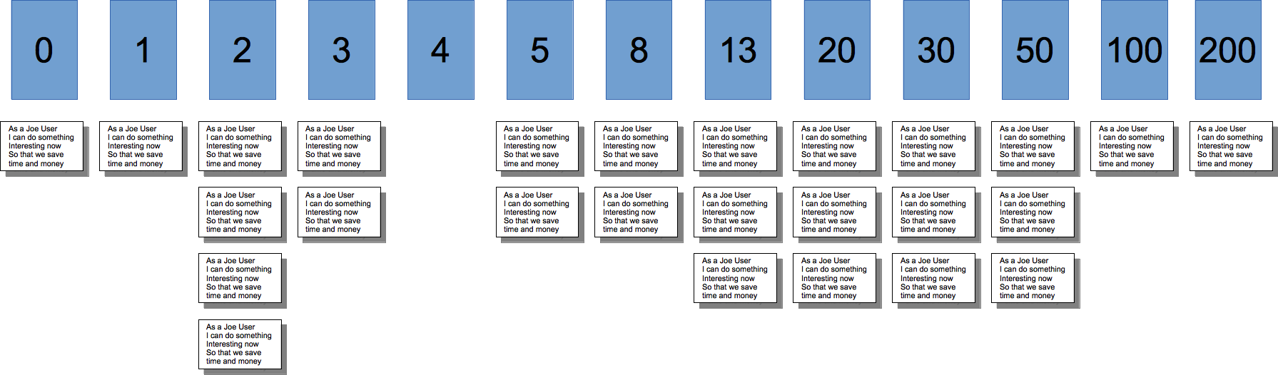
- When the sanity check is complete, items have their
bucket number written on them in an appropriate spot.

